English I Honors
Weekly Letter 4
September 4 - 8

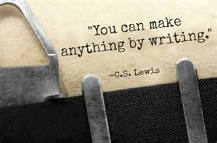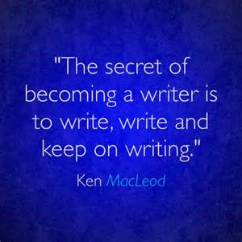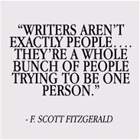

Last week you engaged in sophisticated conversations/Socratic Seminars about overarching questions about writing, synthesis, and process. In addition, in your reaction paper and notes, you recorded helpful writing tips from Steven Frank’s The Pen Commandments. These discussions invited you to dissect the craft of writing and highlight how many ways a writer can illustrate life-lessons. My hope is that this investigative process of writing showcases that being a writer is a life-long process. We will continue to read and reflect this week on our own writing and the writing of others to proclaim that one word/diction choice, if used purposefully, can leave a lasting impact on the reader. Moreover, a few words strung together, can leave a mark on an audience as well. You are learning that these authorial choices help readers to critically think about construction, content, and meaning.
Furthermore, the process of reading critically helps you become a better writer. Better reader—Better Writer! Get it?!!! And because you have carefully explored the text (The Pen Commandments) , you can find the BEST text evidence to support your claim. What do I mean by BEST? I mean, that you can look beyond the first, or most obvious TE, and look for the nuanced text presented by the critical analysis. This helps you select 4-level-quality text evidence for your body paragraphs. This is the growth I hope for you this year. Dig deeper….find more….learn more----and most importantly----know why!

Learning Goals this week: Writing Process
- Use available technology to compose text.
- Reread and analyze clarity of writing, consistency of point of view and effectiveness of organizational structure.
- Rearrange words, sentences, and paragraphs, and add transitional words and phrases to clarify meaning and maintain consistent style, tone, and voice.
- Use resources and reference materials (e.g., dictionaries and thesauruses) to select effective and precise vocabulary that maintains consistent style, tone, and voice.
- Proofread writing, edit to improve conventions (e.g., grammar, spelling, punctuation, and capitalization), identify and correct fragments and run-ons and eliminate inappropriate slang or informal language.
- Apply tools (e.g., rubric, checklist, and feedback) to judge the quality of writing.
- Prepare for publication (e.g., for display or for sharing with others) writing that follows a manuscript form appropriate for the purpose, which could include such techniques as electronic resources, principles of design (e.g., margins, tabs, spacing, and columns) and graphics (e.g., drawings, charts, and graphs) to enhance the final product.

M: No School: Labor Day
T: Revisit/Reflect on Writing:
Groups---helpful tips for writing---The Pen Commandments
Apply the tips-------class reflection and writing

W: Essay models and rewriting sentences to meet rubric standards

TH: Revisit On-Demand Essay----Look at the components of an expository essay from rubric and look
Look at new challenges this year: Look at Expository Rubric (interdisciplinary rubric/vs rubric with specific writing learning goals)
- Structure---is it mastered? How did you set up essay? --label
- Lead/Hook---Did you hook with a rhetorical question? If so, challenge yourself to add anecdote and analogy to your repertoire.
- Text Evidence---it is 4-level? Did you first answer that came to your head or did you choose the best/most nuanced answer? Push yourself to nuance----I can help. Do you know how to keep answers concise without summary to redundancy? Let’s take a look
- Commentary: Ahhh, Analysis or should I say, “The Onion”. Did you peel back a few layers? Get deeper and more sophisticated in your thinking? Connect with thesis? Synthesize?
- Transitions: How does your writing flow? Connect? Move? Writing is a fluid moment…..Do you use transitions? Do you have a wide range of ones to choose from in your craft?
- Diction: What words to you choose in your writing? Are they appropriate to the purpose of the writing? Appropriate to the audience? Voice? Did you add imagery and flavor?
HMWK: Read an essay provided and grade it based on the rubric.
F: Independent Reading (15 minutes + log)
Rewriting the essay---bring chrome book
HMWK: New draft on Monday—we will start Of Mice and Men on Monday, September 11th

